Instalar o speechsdk51.exe
Abrir o projeto do quad que está no zip JAVA_TO_SAPI_ver2-5.zip
sobreescrever o sphelper.h
Inserir o paths
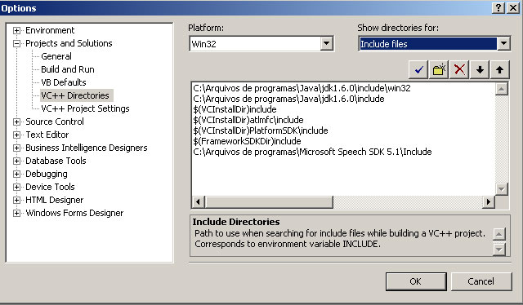

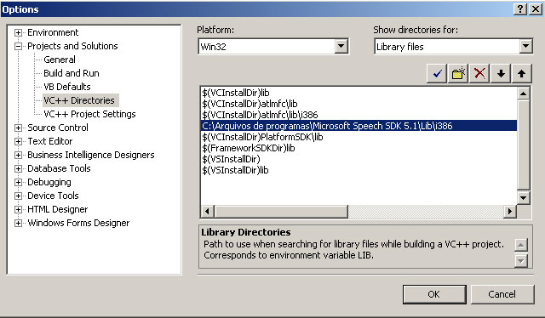

USING THE DLL FROM A JAVA PACKAGE
Many thanks to Ronnie Tsz Kit Cheung for providing the following tutorial steps.
The following example uses the DLL Version 1.1 code, but the technique is easily imitated for later versions.
1) Edit the QuadmoreJNI.java and/or SR.java file to add the package "com.quadmore.dev" (for example) on the first line;
2) Compile the .java file(s) into a .class the regular way;
3) Open a DOS command prompt and change to the directory to where the file QuadmoreJNI.class is;
4) Use the command: (path)\javah.exe -jni QuadmoreJNI
5) Change to the directory where SR.class is;
6) Use the command: (path)\javah.exe -jni SR
7) Copy the generated QuadmoreJNI.h and SR.h files into the VC++.NET project directory;
8) Open the solution file in VC++.NET;
9) Edit the QuadmoreJNI.h file, modifying Java_QuadmoreJNI_SpeakDarling into Java_com_quadmore_dev_QuadmoreJNI_SpeakDarling
where 'com.quadmore.dev' is the package name and underscore is the separator (reference: http://java.sun.com/docs/books/tutorial/native1.1/integrating/declare.html)
10) Similarly, modify the file SR.h to replace Java_SR_TakeDictationDear with
Java_com_quadmore_dev_SR_TakeDictationDear
11) Since Quadmore.h have included both QuadmoreJNI.h and SR.h, similar modifications are needed: change
Java_QuadmoreJNI_SpeakDarling
into:
Java_com_quadmore_dev_QuadmoreJNI_SpeakDarling
and replace:
Java_SR_TakeDictationDear
with:
Java_com_quadmore_dev_SR_TakeDictationDear
12) Rebuild the VC++.NET project and place the dll in your library path, (normally %systemroot%system32 on Windows machines).
13) Now the methods 'SpeakDarling' and 'TakeDictationDear' can be invoked from within the 'com.quadmore.dev' package.

